**Introduction**

As a Bangladeshi people we have a soft corner in cricket and education.That’s why I decide to create a website based on education and cricket in a single frame initially.In future if it works well then make it dynamically.

**Methodology**

In HTML I use Header,paragraph,inline,display,list,nivo-slide bar,img,id, class,body,title,src,etc

In CSS I use Border,border-radius,padding,margin,float,top,left,background-color,color, background-image, background-size,size-boxing,font-familly,font-style,list-style-type,text-align,align,z-index,keyframes,animation,transition,translate,etc

In Java-Script I use Window.alert,window.prompt,window.confirm,variable,function,condition,if,else if,else,operator,etc

In Php/Data Base & Mysql I use Search,name,email,player name,student name match,query,etc

**Result And Anlysis** **Home page**

Home page is first page.I added login page in home page and connect with forgot password page and register pag. In navigation bar connect the education page, cricket page, gallery page etc. I added nivo-slider in our home page. I also add 10 meaning full images and when the curser hover the images it will change design.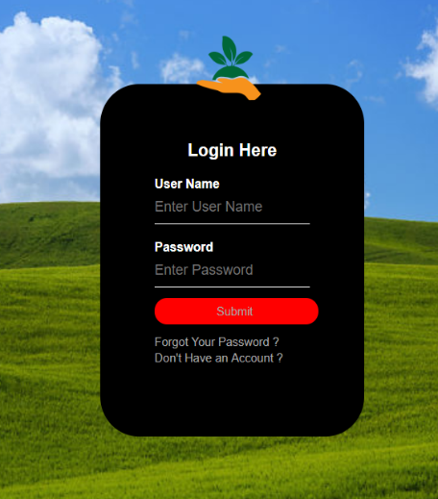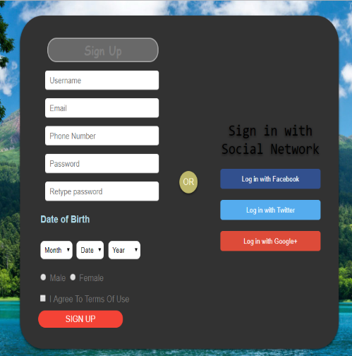

**Education page**

There are some paragraph, heading, images, slide bar, teachers schedule, students schedule in the slide bar.

And in navigation bar, there are students results, students informations, forms, standard calculator, standard calendar etc. These type of page been added in my education page.

I added 10 batchs for students results and informations. Every batch have around 20 students data; like, student name, id, age, blood group, image, home town, cgpa.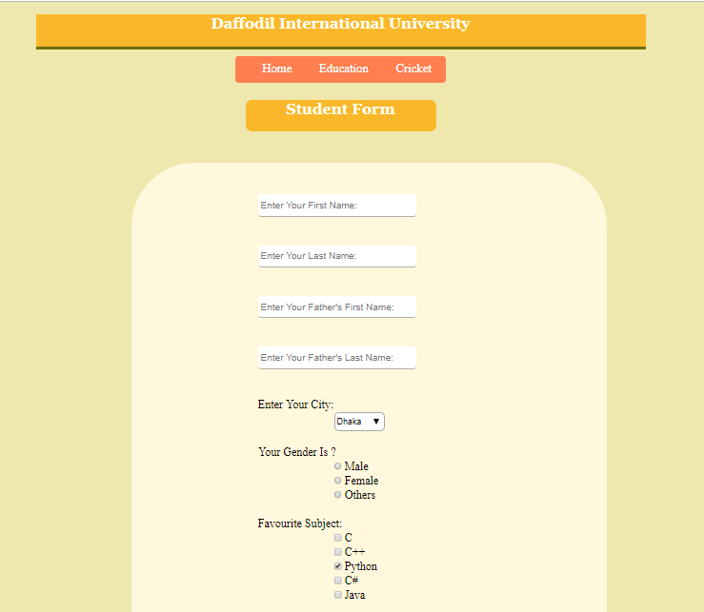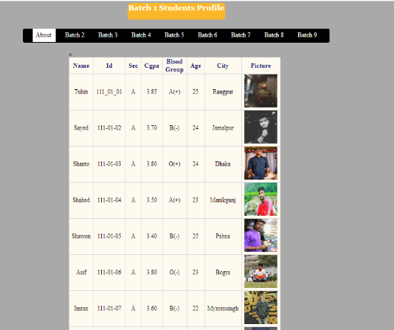 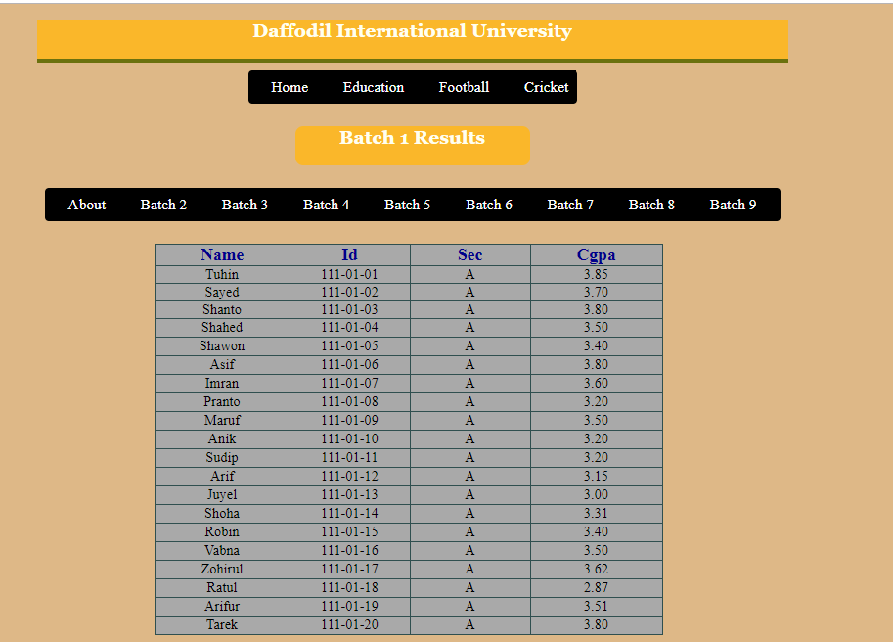 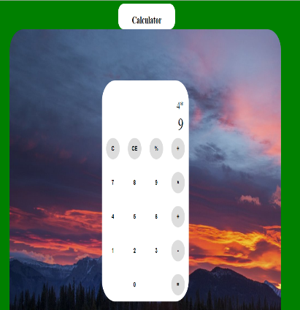 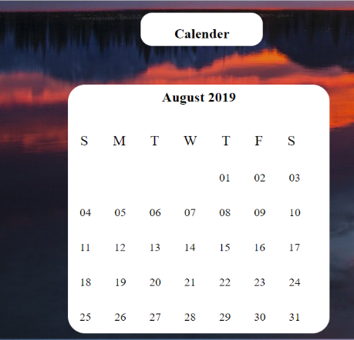

**Cricket page**

I added 300 html pages for each players from Bangladesh, India, Pakistan, And other Countrys. From Bangladesh I added 30 players, From India I added 40 players, From Pakistan *I* added 40 players, and From Others I added 100 players.

For Each Player

If he is a batsman I add his Career total runs, total match numbers, Highest Run, Total 100s, Total 50s, Average Run, Strike rate, etc.

If he is a bowler I add his total wickets, total match numbers, total five wickets in a match, best figure in a match.

If he is an all-rounder I add both bating and bowling stats.

If he is a wicket keeper batsman then I add his batting and Wicket keeping stats.

And these informations are in all three categories like Test, Odi, T-20 of each playeres.

I also add picture, hometown, role in national team and names of all the club teams he played for.

I assure that All informations are appropriate of each players. I Collect these data from google, cricbuzz, cricin

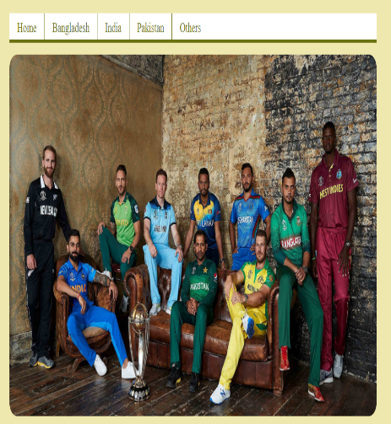 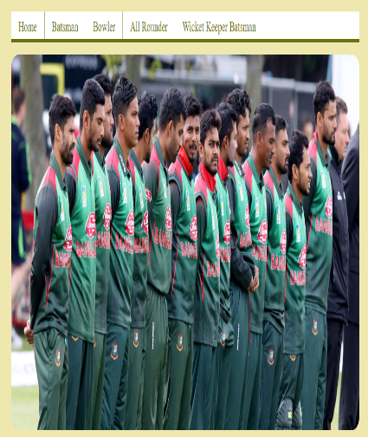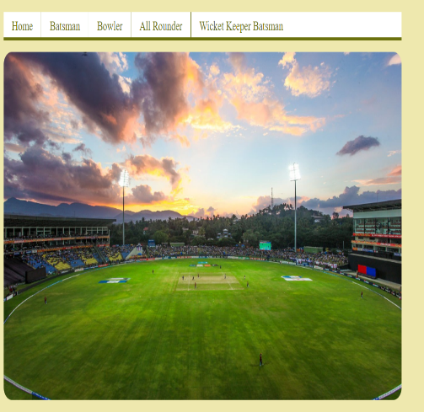 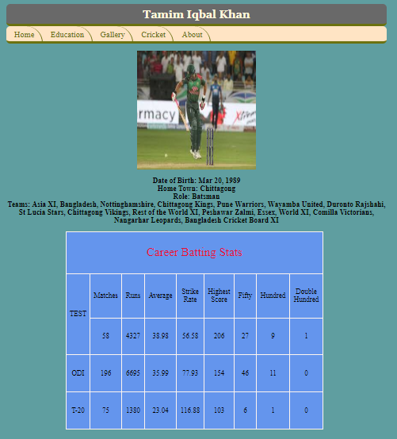 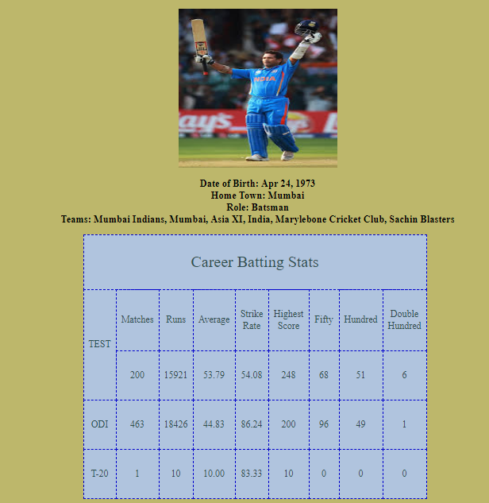

**About Page:**

In About Page I added cricket,education Description..

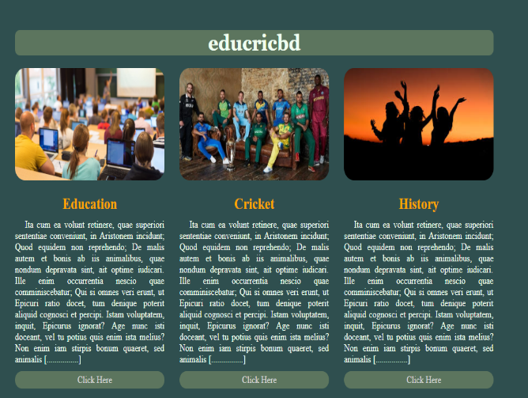

**Animation Page & Gallery page :**

I added 100 pictures and use css to design the page. Rotate picture, change border radius, scale size, background-color change, image size change etc.

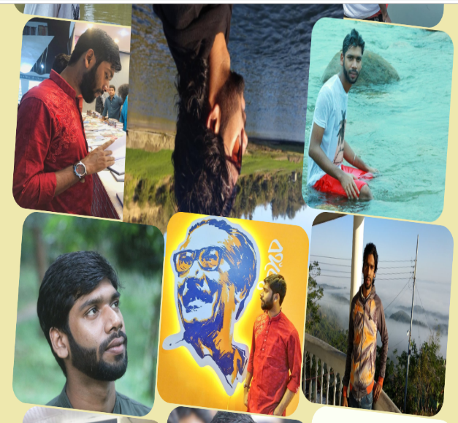 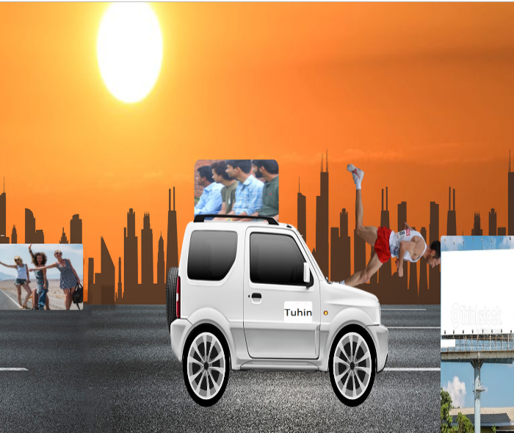

**Data** **Set**

There are two type of data set.one is training another is test.In training set store the input data. And in test compare the data with the training data.In Login page use the dataset.If password and user Name match then successfully Login.There Are around 1000 image as a training data set for cricketer, students, gallery,home page.

**Limitation**

There are no database include in my website.Initially my web site is static web site.I am trying to build dynamic web site.There is no search option in my web site.Now education and cricket in a same frame in my web site.In future separate education and cricket in different frmae.Cricket score update system is not found in my web site.

**Accuracy**

In previous cricket and education web site they can provie 80% Accuracy. Some web site have 90% Accuracy.But Overall level of the Accuracy from the web site experiment does not meet high.In my web site I am trying to increase the Accuracy.

**REFERENCES**

1->Cricbuzz.com-

2->Cricinfo.com

3->Vcricket.com

4->twitter.com/icc

5->twitter.com/bcb

6-> twitter.com/pcb

7-> twitter.com/bcci

8-> twitter.com/education

9->w3school.com

10->programiz.com

11->satckoverflow

12->geeksforgeeks.com